### KLS, Gogte Institute of Technology, Belagavi

### Department of Chemistry



**A Seminar Report** on

“NON-NEWTONIAN FLUID”

**Submitted by**

|  |  |  |  |
| --- | --- | --- | --- |
| Name | Roll No. | USN | Sign |
| **OMPRAKASH JATT** |  |  |  |
| **SHRADHA PATIL** |  |  |  |
| **SMRUTI B** |  |  |  |
| **BASAVRAJ R DUGANAVAR** |  |  |  |

|  |  |  |  |  |  |  |
| --- | --- | --- | --- | --- | --- | --- |
|  | Batch No. : | | | | | |
| 1. | Seminar Title: | Marks Range | ROLL NUMBERS | | | |
|  |  |  |  |
| 2. | Introduction (PO2) | 0-2 |  |  |  |  |
| 3. | Application of the topic to the course (PO2) | 0-3 |  |  |  |  |
| 4. | References / Literature survey(PO2) | 0-4 |  |  |  |  |
| 5. | Methodology, Results and Conclusion (PO1,PO3,PO4) | 0-6 |  |  |  |  |
| 6. | Report and Oral presentation skill (PO9,PO10) | 0-5 |  |  |  |  |
|  | Total | 20 |  |  |  |  |

Guidance by: Dr. Prasanna S. Koujalagi, Asst. Prof., Dept. of Chemistry, GIT.

**CONTENTS:**

1. **ABSTRACT AND INTRODUCTION**
2. **WORKING OF NON-NEWTONIAN FLUID**
3. **USAGE IN DAY TODAY LIFE**
4. **EXAMPLES FOR NON-NEWTONIAN FLUID**

* **OOBLECK**
* **FLUBBER**
* **SILLY PUTTY**
* **PLANT RESIN**
* **QUICK SAND**
* **KETCHUP**

1. **ADVANCE USES OF NON-NEWTONIAN FLUID**
2. **CONCLUSION**
3. **REFERENCES**

**ABSTRACT**

**The objective of this topic is to introduce and to illustrate the frequent and wide occurrence of Non-Newtonian fluid behavior in a diverse range of applications, both in nature and in technology. Starting with the definition of a Non-Newtonian fluid, different types of Non-Newtonian characteristics are briefly described. Representative examples of materials (foams, suspensions, polymer solutions and melts), which, under appropriate circumstances, display shear-thinning, shear-thickening, visco-plastic, time-dependent and visco-elastic behavior are presented. Each type of Non-Newtonian fluid behavior has been illustrated via experimental data on real materials. This is followed by a short discussion on how to engineer Non-Newtonian flow characteristics of a product for its satisfactory end use by manipulating its microstructure by controlling physico-chemical aspects of the system. Finally, we touch upon the ultimate question about the role of Non-Newtonian characteristics on the analysis and modeling of the processes of pragmatic engineering significance.[1]**

**INTRODUCTION**

**WHAT IS NON-NEWTONIAN FLUID?**

**A Newtonian fluid is defined as one with constant viscosity, with zero shear rate at zero shear stress, that is, the shear rate is directly proportional to the shear stress**.

**σyx = F/A = ηγyx**

**Viscosity remains constant, no matter how fast they are forced to flow through a pipe or channel. But the viscosity of some fluids is affected by factors other than temperature. These fluids are termed non-Newtonian fluids**. [3]

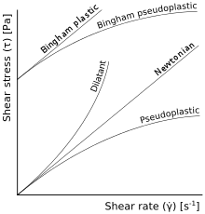

**WORKING OF NON-NEWTONIAN FLUID**

**Non-Newtonian fluids change their viscosity or flow behaviour under stress. If you apply a force to such fluids (say you hit, shake or jump on them), the sudden application of stress can cause them to get thicker and act like a solid, or in some cases it results in the opposite behaviour and they may get runnier than they were before. Remove the stress (let them sit still or only move them slowly) and they will return to their earlier state.[2]**

**USAGE IN DAY TODAY LIFE[3]**

**Many common substances exhibit non-Newtonian flows. These include:**

* **Soap solutions, cosmetics, and toothpaste.**
* **Food such as butter, cheese, jam, mayonnaise, soup, taffy, and yogurt.**
* **Natural substances such as magma, lava, gums, honey, and extracts such as vanilla extract.**
* **Biological fluids such as blood, saliva, semen, mucus, and synovial fluid.**
* **Slurries such as cement slurry and paper pulp, emulsions such as mayonnaise, and some kinds of dispersions.**
* **And some more examples are:**

1. **OOBLECK**

**An inexpensive, non-toxic example of a non-Newtonian fluid is a suspension of starch (e.g., corn-starch) in water, sometimes called "oobleck", "ooze", or "magic mud".**

**Because of its properties, oobleck is often used in demonstrations that exhibit its unusual behaviour. A person may walk on a large tub of oobleck without sinking due to its shear thickening properties, as long as the individual moves quickly enough to provide enough force with each step to cause the thickening. Also, if oobleck is placed on a large subwoofer driven at a sufficiently high volume, it will thicken and form standing waves in response to low frequency sound waves from the speaker. If a person were to punch or hit oobleck, it would thicken and act like a solid. After the blow, the oobleck will go back to its thin liquid-like state.**

1. **FLUBBER [SLIME]**

**Flubber, also commonly known as slime, is a non-Newtonian fluid, easily made from polyvinyl alcohol–based glues (such as white "school" glue) and borax. It flows under low stresses but breaks under higher stresses and pressures. This combination of fluid-like and solid-like properties makes it a Maxwell fluid. Its behavior can also be described as being viscoplastic or gelatinous.**

1. **SILLY PUTTY**

**Silly Putty is a silicone polymer based suspension which will flow, bounce or break depending on strain rate**.

1. **PLANT RESIN**

**Plant resin is a viscoelastic solid polymer. When left in a container, it will flow slowly as a liquid to conform to the contours of its container. If struck with greater force, however, it will shatter as a solid.**

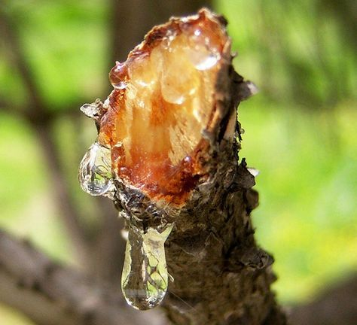

1. **QUICKSAND**

**Quicksand is a shear thinning non-Newtonian colloid that gains viscosity at rest. Quicksand's non-Newtonian properties can be observed when it experiences a slight shock (for example, when someone walks on it or agitates it with a stick), shifting between its Gel and Sol phase and seemingly liquefying, causing objects on the surface of the quicksand to sink**.

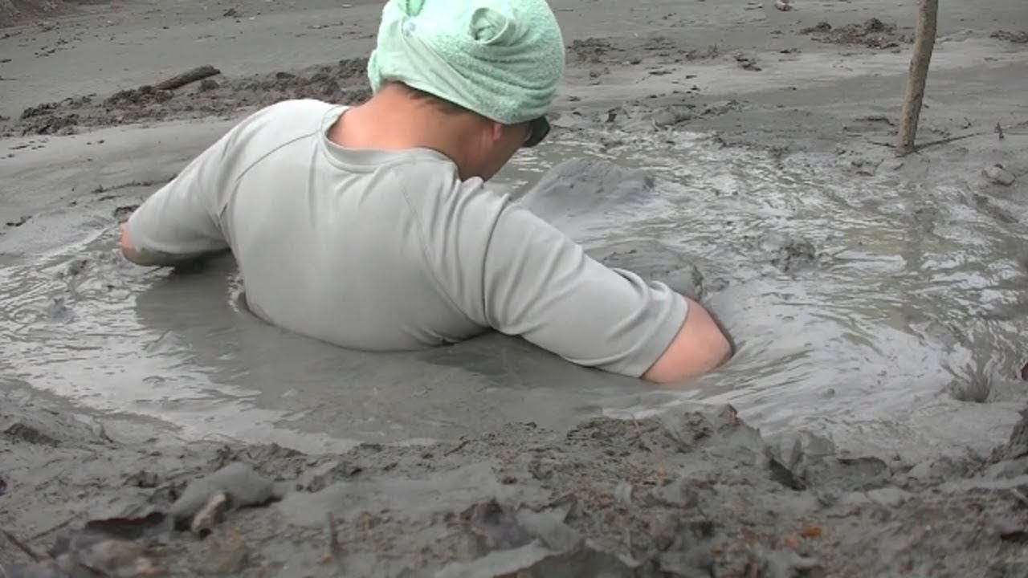

1. **KETCHUP**

**Ketchup is a shear thinning fluid. Shear thinning means that the fluid viscosity decreases with increasing shear stress. In other words, fluid motion is initially difficult at slow rates of deformation, but will flow more freely at high rates. Shaking an inverted bottle of ketchup can cause it to transition to a lower viscosity, resulting in a sudden gush of the shear thinned condiment.**

**ADVANCE USES OF NON-NEWTONIAN FLUID**

* **the application provides a system of temporarily fixing potholes by filling them with bags of oobleck (or other non-Newtonian fluids). When the bag is placed in the pothole, the oobleck has time to act like a fluid and fill the hole.**
* **Created by the Moratex Institute of Security Technologies, the liquid is what's known as a non-Newtonian fluid. ... The institute is being tight-lipped on what exactly their fluid is made of, but they revealed that when fitted in a vest, it's capable of stopping bullets fired at 450 metres (or 1,400 feet) per second.**
* **The use of surfactants in district and building heating and cooling systems is an emerging technology with great promise for significant energy savings. By incorporating non-Newtonian properties into a dye-streak, a highly effective flow tracer has been developed.**
* **The non-Newtonian tracer is developed using ideas based on drag-reduction technology. The basic concept is to incorporate both the shear-induced-state (SIS), sometimes referred-to as shear thickening or strain-hardening flow aspects found in surfactant solutions, with the high extensional viscosity or thread-drawing properties of polymer solutions. These are then used to form (with a colorant) a tracer fluid that can be ejected into the turbulent flow as a dye-streak which resists dispersion and breakup while following the flow path**.
* **Non-Newtonian characteristics are typical of a wide variety of fluids, such as concentrated and dilute polymer solutions, polymer melts, filled polymer melts, suspensions of particles, suspensions of immiscible liquids and surfactant solutions**.
* **The applications where their presence changes heat transfer characteristics are, for example, manufacture of plastic products by injection and extrusion, the production of paints, food products, and chemicals. The use of non-Newtonian drag reducing fluids in central heating systems is known to be in practice in Japan. There has, therefore, been a lot of research interest in the field of non-Newtonian fluid heat transfer.**

**CONCLUSION**

* **Fluids generally have little resistance to forces moving through them, and OOBLECK is no exception. However, the unique property of OOBLECK, which is a mixture of cornstarch and water, is that at a specific concentration, the amount of cornstarch particles in the mixture becomes suitable to make the viscosity of the fluid increase.**
* **At that concentration, the OOBLECK becomes a non-Newtonian fluid.  It is so called because it defies Newton’s third law of motion, which is simply stated as, to every action, there is an equal and opposite reaction. If it obeyed this law, we would expect the applied force to cause the OOBLECK to splash!**
* **non-Newtonian fluids, are pressure dependant. When a quick and strong pressure is applied, viscosity increases and it could act as a solid if the pressure is high enough and the concentration of the fluid is optimum. Cornstarch contains amylose, a long polymer of alpha glucose. Cornstarch mixed with water forms a suspension, which implies the starch molecules do not dissolve.**
* **The difference in the forces between starch molecules and water account for this observation. When a quick and strong pressure is applied, the long polymer chains of starch get tangled up because they have less time to move. This increases the viscosity of the fluid. A slow and weak pressure will allow more time for the polymers to move hence making it act as a liquid.[4]**

**REFERENCES**

**[1]** [**https://physics.iitm.ac.in/~compflu/Lect-notes/chhabra.pdf**](https://physics.iitm.ac.in/~compflu/Lect-notes/chhabra.pdf)

**[2]** [**https://www.sciencelearn.org.nz/resources/1502-non-newtonian-fluids**](https://www.sciencelearn.org.nz/resources/1502-non-newtonian-fluids)

**[3]** [**https://en.wikipedia.org/wiki/Non-Newtonian_fluid#Examples**](https://en.wikipedia.org/wiki/Non-Newtonian_fluid#Examples)

**[4]** [**https://pearson20.wordpress.com/2014/04/06/conclusion-finally/#:~:text=Fluids%20generally%20have%20little%20resistance,and%20OOBLECK%20is%20no%20exception.&text=At%20that%20concentration%2C%20the%20OOBLECK%20becomes%20a%20non%2DNewtonian%20fluid**](https://pearson20.wordpress.com/2014/04/06/conclusion-finally/#:~:text=Fluids%20generally%20have%20little%20resistance,and%20OOBLECK%20is%20no%20exception.&text=At%20that%20concentration%2C%20the%20OOBLECK%20becomes%20a%20non%2DNewtonian%20fluid)